**Name**: Shubham Lad

**Class**: MSc Computer Science (Part 1)

**Roll No**: 512

**Semester**: II

**Subject**: Social Network Analysis

**Topic**: Sentiment Analysis

**Social Network Analysis**

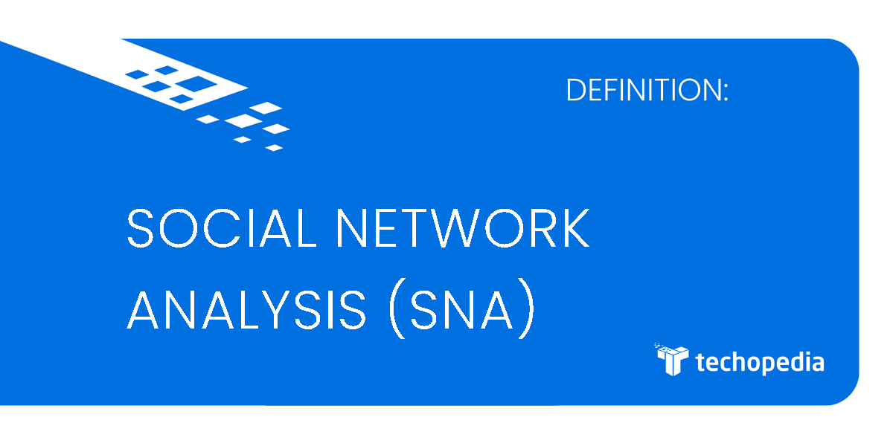

The practise of quantitative and qualitatively analysing a social network is called social network analysis (SNA). Between entities that contain information, SNA tracks and maps the flow of relationships and relationship modifications. Sites on the internet, computers, animals, people, groups, organisations, and nations are examples of simple and complex things.

Humans are examples of node entities in the SNA structure, while relationships are examples of ties. Modern cognition and computers enabled the notion of social networking to gradually evolve into extremely sophisticated, graph-based networks with a wide variety of nodes and linkages. These networks are essential to processes and projects including administration, operations, and issue solving.

**Sentiment Analysis**

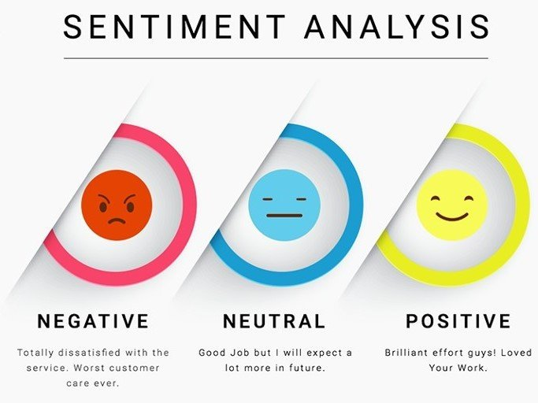

The method of determining whether a block of text is good, negative, or neutral is known as sentiment analysis. Sentiment analysis is the contextual mining of words that reveals the social sentiment of a brand and aids businesses in determining whether or not the product they are producing will find a market. Sentiment analysis's objective is to examine public sentiment in a way that will support corporate growth. It emphasises emotions as well as polarity (positive, negative, and neutral) (happy, sad, angry, etc.). Rule-based, automatic, and hybrid natural language processing methods are used.

**Why perform Sentiment Analysis?**

80% of the data in the globe is unstructured, according to the report. Regardless matter whether the data is in the form of emails, messages, papers, articles, or anything else, it has to be analysed and organised.

* Sentiment analysis is necessary since it saves data effectively and affordably.
* Sentiment analysis can assist you in resolving any real-world problems and situations.

**Source Code (Jupyter Notebook)**

# 512 Shubham Lad

## Install and Import Dependencies

!pip install torch==1.8.1+cu111 torchvision==0.9.1+cu111 torchaudio===0.8.1 -f <https://download.pytorch.org/whl/torch_stable.html>

!pip install transformers requests beautifulsoup4 pandas numpy

from transformers import AutoTokenizer, AutoModelForSequenceClassification

import torch

import requests

from bs4 import BeautifulSoup

import re

## Instantiate Model

tokenizer = AutoTokenizer.from_pretrained('nlptown/bert-base-multilingual-uncased-sentiment')

model = AutoModelForSequenceClassification.from_pretrained('nlptown/bert-base-multilingual-uncased-sentiment')

## Encode and Calculate Sentiment

tokens = tokenizer.encode('It was good but couldve been better. Great', return_tensors='pt')

result = model(tokens)

result.logits

int(torch.argmax(result.logits))+1

## Collect Reviews

r = requests.get('https://www.yelp.com/biz/social-brew-cafe-pyrmont')

soup = BeautifulSoup(r.text, 'html.parser')

regex = re.compile('.*comment.*')

results = soup.find_all('p', {'class':regex})

reviews = [result.text for result in results]

reviews

## Load Reviews into DataFrame and Score

import numpy as np

import pandas as pd

df = pd.DataFrame(np.array(reviews), columns=['review'])

df['review'].iloc[0]

def sentiment_score(review):

tokens = tokenizer.encode(review, return_tensors='pt')

result = model(tokens)

return int(torch.argmax(result.logits))+1

sentiment_score(df['review'].iloc[1])

df['sentiment'] = df['review'].apply(lambda x: sentiment_score(x[:512]))

df

df['review'].iloc[3]

